**The wedding**

**Home page**

**\* header**

**(right side)**

1. **Language (Hindi, Eng.)**
2. **Login**
3. **Signup/register**
4. **Add property (Button)**

**\*** **Navigation Bar**

**Logo**

1. **Vendors**

* **DJs**
* **transport**
* **choreograhers**
* **wedding planners**
* **makeup artists**
* **mehendi artists**
* **decorators**
* **photographers**
* **tailoring**
* **gifting**

1. **wear shop**

* **men**
* **women**
* **kids**

1. **grocery shop**

* **vegetable**
* **fruit**
* **dairy**

1. **about us**

**\*searching**



City

Date

**\* Amenities**



**\*latest wedding hall listing (image slider)**

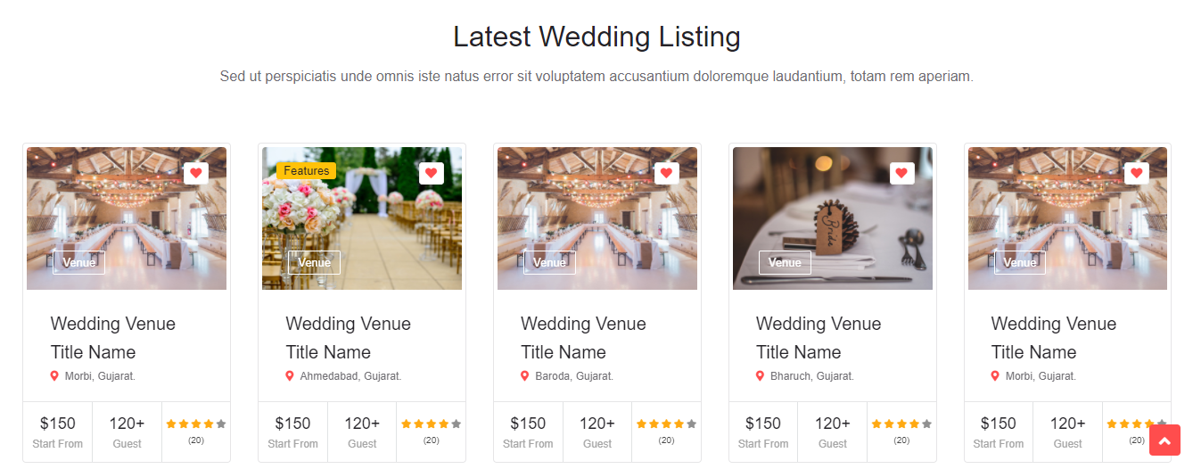

**\*after searching list**

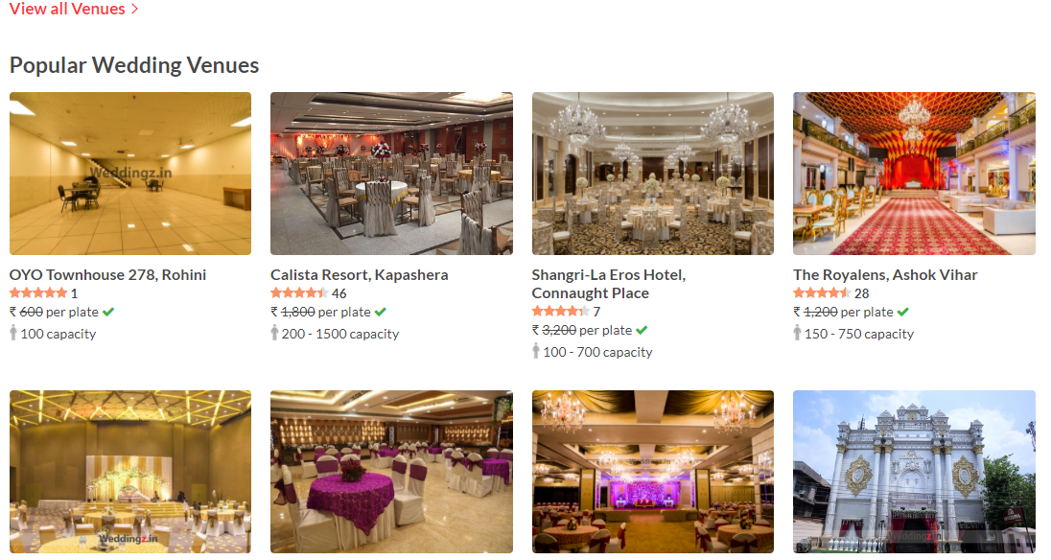



**\*footer**

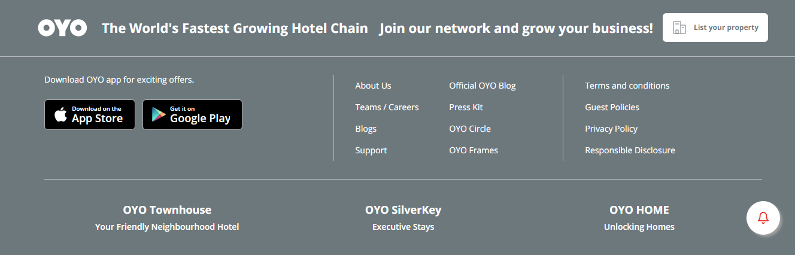

[**https://jituchauhan.com/real-wed/realwed/index-4.html**](https://jituchauhan.com/real-wed/realwed/index-4.html)

[**https://jituchauhan.com/wedding/wedding-new/index-2.html**](https://jituchauhan.com/wedding/wedding-new/index-2.html)

**login page**

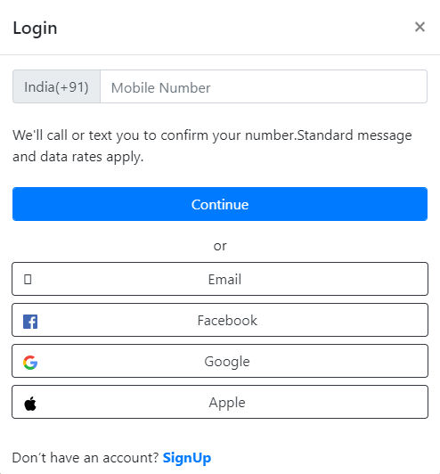

**Number verification**

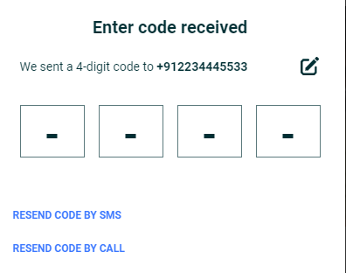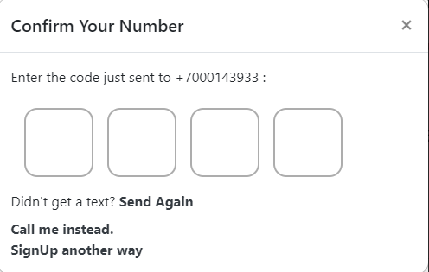

**Mail verification**

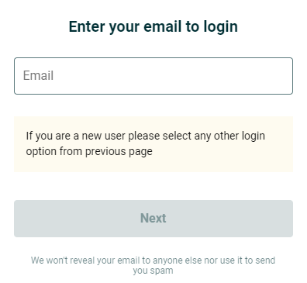

**New registration**

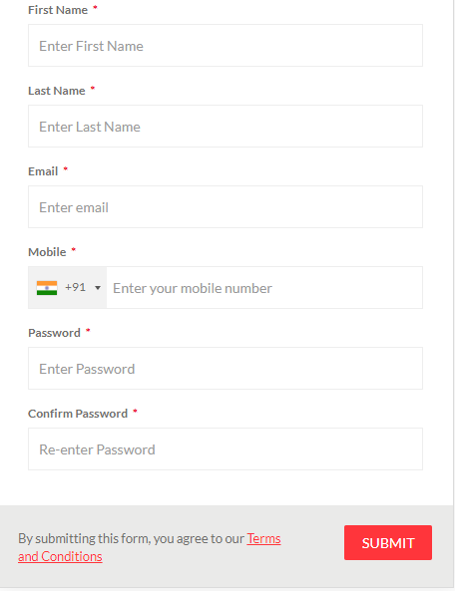

**add property hotel and gardens**

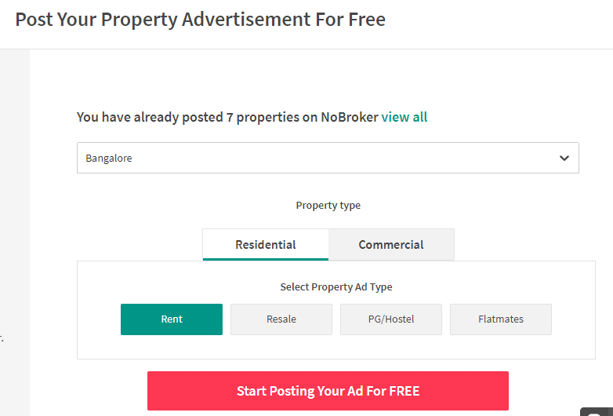

Gardens

Hotels

**Hotels owner registration :**

Type of hotels:

Hotel name:

Hotel owner name (hide):

Address: location

Area: guest’s hall size(Poolside Hall Seating:200, Max Capacity:300,)

Number: owner mobile no. (temporary mobile number and virtual number)

Plate price: per plate

Amenities: Changing Room , Parking At, Alcohol, Decoration, Halls are air conditioned, Fire crackers allowed, Baarat allowed, Overnight wedding allowed

Description: about the hotel

Photos/images: 6-10 (automated compress format png photo)

* **Gardens owner registration:**

Type of wedding garden:

Garden name:

Garden owner name (hide):

Address: location

Area: guest’s size(sqf)

Number: owner mobile no. (temporary mobile number / virtual number)

Plate price: per plate(depend on the caterers)

Amenities: Changing Room , Parking At, Alcohol, Decoration, Halls are air conditioned, Fire crackers allowed, Baarat allowed, Overnight wedding allowed

Description: about the hotel

Photos/images: 6-10 (automated compress format png photo)

* **What should come after clicking the button?**



[**https://weddingz.in/party-halls/delhi/all/**](https://weddingz.in/party-halls/delhi/all/)

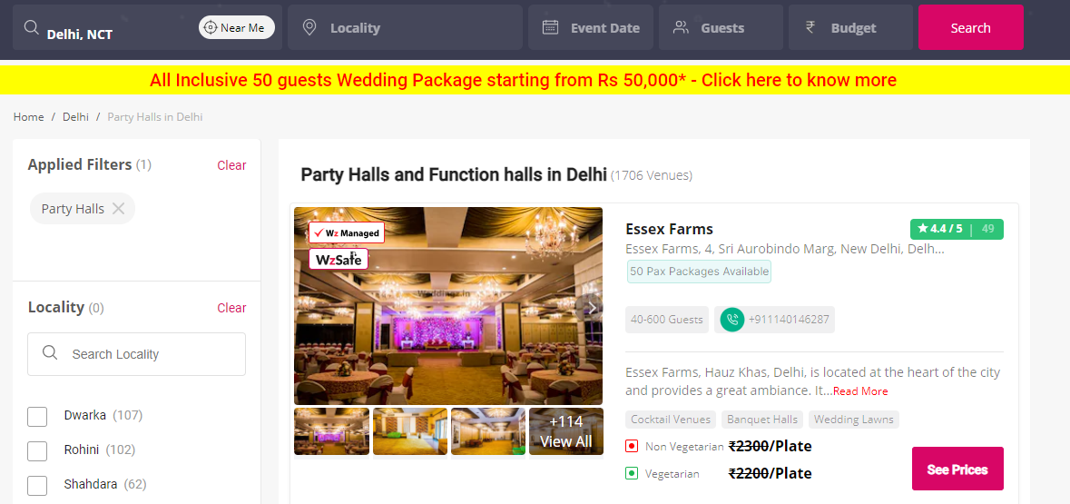

* **Click the list item:**

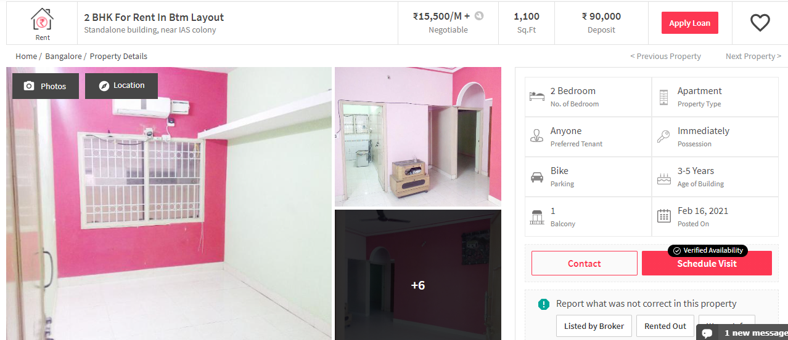

**On this page, we will pay maximum attention to date and payment options.**

**1) date:** **calendar (red and green colour is selected or not )**

**2) payment: deposit amount**

[**https://www.oyorooms.com/20044/?checkin=15%2F02%2F2021&checkout=16%2F02%2F2021&guests=1&modal=bookingSummary&rooms=1&rooms_config=1-1_0&selected_rcid=1**](https://www.oyorooms.com/20044/?checkin=15%2F02%2F2021&checkout=16%2F02%2F2021&guests=1&modal=bookingSummary&rooms=1&rooms_config=1-1_0&selected_rcid=1)

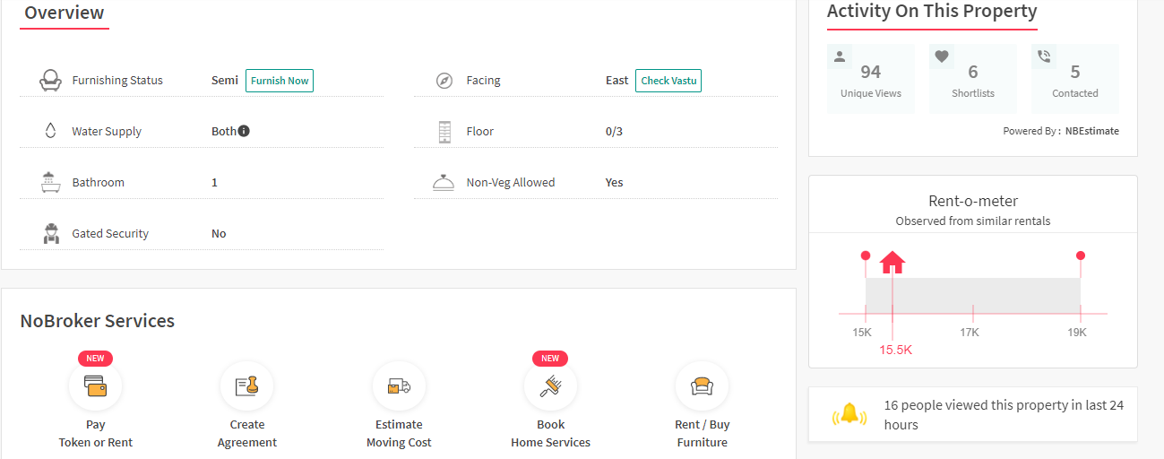

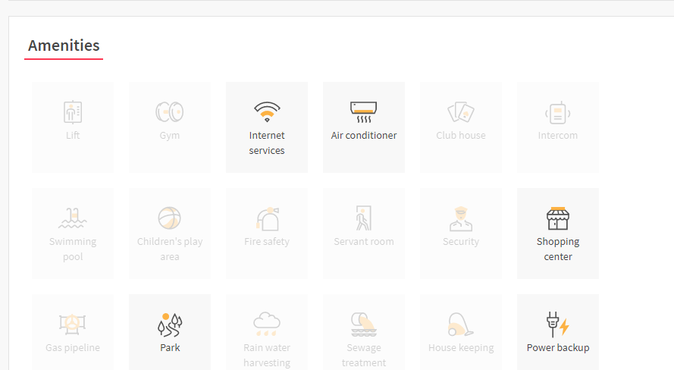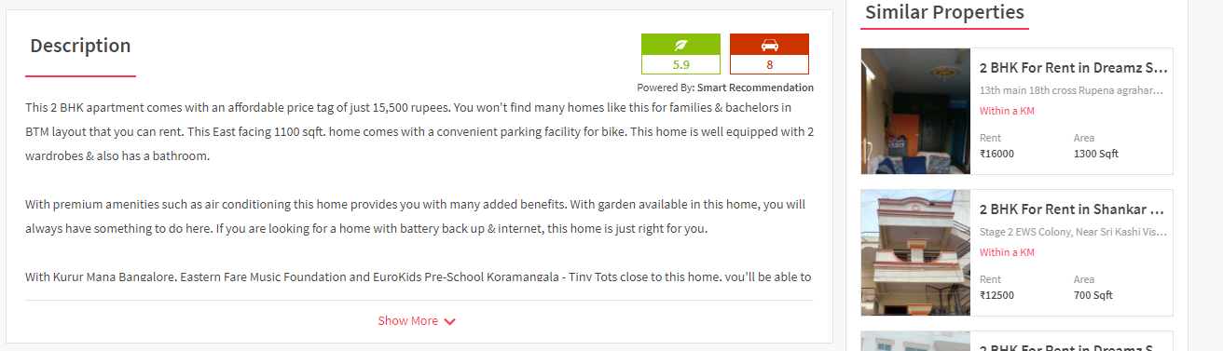

[**https://www.nobroker.in/property/2-bhk-apartment-for-rent-in-btm-layout-bangalore-for-rs-15500/ff8081815322acc501533d0f5e95229e/detail**](https://www.nobroker.in/property/2-bhk-apartment-for-rent-in-btm-layout-bangalore-for-rs-15500/ff8081815322acc501533d0f5e95229e/detail)

[**https://weddingz.in/gwalior/radisson-gwalior-city-center/**](https://weddingz.in/gwalior/radisson-gwalior-city-center/)

